Project Design
Phase Problem – Solution Fit Template

Date | 02 Nov 2025
Team ID | NM2025TMID06777
Project Name | Optimizing User, Group, and Role  Management with Access Control and Workflows
Maximum marks | 4 marks

Problem – Solution Fit Template:
The team initially struggled with unclear role definitions, ineffective task tracking, and a lack of proper access control in project management. To address these issues, a solution was implemented in ServiceNow that established well-defined users, groups, and roles using Access Control Lists (ACLs) and automated workflows. This approach ensured secure access, efficient task assignment, and streamlined approval processes. As a result, the system significantly improved accountability, security, and overall project efficiency.
Purpose:
- To develop a clear and secure system for managing users, groups, and roles within the ServiceNow platform.
- To enhance workflow efficiency through automated task assignments and approval mechanisms.
- To ensure accountability and protect data by implementing robust Access Control Lists (ACLs).
- To strengthen project collaboration by clearly defining structured roles and responsibilities for each team member.
- To simplify project tracking and communication, enabling faster task completion and improved team coordination.

Template:
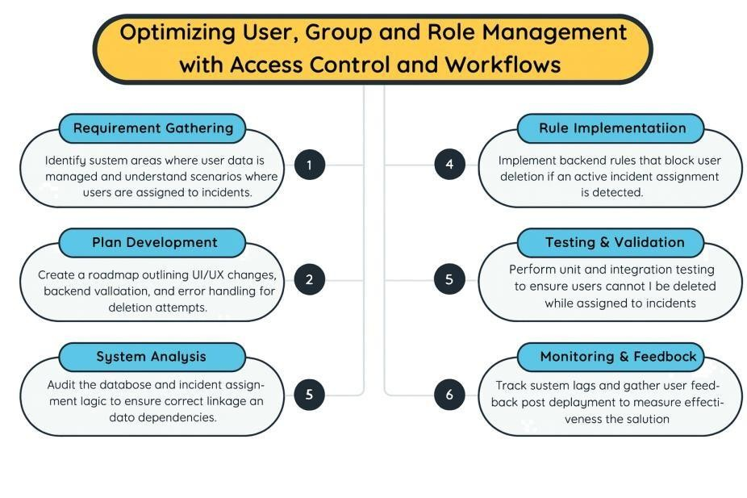
The project, "Optimizing User, Group, and Role Management with Access Control and Workflows," aims to enhance security, accountability, and workflow efficiency within project management systems. By clearly defining user roles, group memberships, and access permissions, the system ensures that team members operate within their designated scope, reducing confusion and preventing unauthorized access. Implementing Access Control Lists (ACLs) and automated workflows in ServiceNow allows tasks to be assigned, monitored, and approved seamlessly, fostering transparency and efficiency throughout the project lifecycle. This structured approach not only streamlines collaboration between project managers and team members but also strengthens data protection and compliance.

